Assignment 1: DIP

Name: Muhammad Umer Javaid

Class: Bese 5a

CMSID: 111238

**Submitted to: Dr Muazzam Faraz**

**Problem 1:**

**Which is the best way to find the difference between two monochrome images, Explain?**

**Answer:**

In order to get difference between two monochrome images pixel wise Subtraction is best solution:

**Justification:**

Imagine we extract 2 frames from a live stream video in which a moving car is observed. Then if we do pixel wise subtraction then all non moving(road) pixels will be set to 0 black. And we have moving object in image which is car. Initially at position x,y and in next frame x+i , y+j so we will have 2 instances of car in such a scenario.  
 We can generalize this behaviors bcz pixel wise subtraction will remove non moving and preserve moving or changed areas in image. Hence We will get Difference

**Problem 2: What will be the resulting monochrome image if you:**

**a. Add a uint8 monochrome image to itself**

Answer:

(Brighter Image) if we add uint8 to itself then all pixels will be shifted towards 255 some might exceed 255 which will be clipped. And hence image will be moved to maximum which is white.

Example pixel at [2,4] =44

after addition it will be 88 (bright)

**b. Add a double monochrome image to itself**

Answer:

(Brighter Image) if we add double itself then all pixels will be shifted towards 1 some might exceed 1which will be clipped. And hence image will be moved to maximum which is white

Example pixel at [2,4] = 0.3

after addition it will be 0.3 (bright)

**c. Multiply a uint8 monochrome image with itself**

Answer:

(Mostly white image) if we multiply uin8 with itself then all pixels will be shifted towards 255(assuming 8bit), in case of multiplication a lot of pixels will be clipped to white and most area will be white.  
Any pixel value >= square_root(maximum) => white  
So mostly image will be white

**d. Divide a uint8 monochrome image from itself**

Answer:

(Black Image) if we divide uin8 with itself then all pixels will 1 , which is closest pixel to 0(black) hence image will be black  
pixel [2,2] = 33  
pixel[2,2]/ pixel[2,2] => 33/33 => 1 => Black

**e. Divide a double monochrome image from itself**

Answer:

(White Image) if we divide double image with itself then all pixels will 1 , which in case of double is maximum possible value(white) and after conversion to uint8 it will be 255.  
pixel [2,2] = 0.4  
pixel[2,2]/ pixel[2,2] => 0.4/0.4 => 1 => white

**Problem 3:**

**An 8-bit image has a minimum grey level of 140 and a maximum grey level of 195 and a maximum grey**

**level of 195. Describe the effect on the histogram of this image after each of these operations is**

**performed (separately):**

**(a) Subtraction of 120 from all pixels gray levels (histogram sliding).**

Answer:

(Shifted towards 0 (left) ) In case of subtraction all pixels will be moved towards dark region and histogram will be shifted to left and will be from (20 -75)

**(b) Histogram stretching**

Answer:

Distance between minimum and maximum will be increased, if previously it was 140-195 then after stretching it might go from 50-240 and all rest of pixels are spreaded in between

**(c) Histogram equalization**

Answer:

In case of equalization our aim would be to take all dynamic range from 0-255 in ideal case we will have a flat histogram which means all bins have same number of pixels.  
But in general equalization will spread dynamic range from 140-195 to 0-255 and will try to assign equal number of pixel to each bin or gray level.

**Problem 4:**

**What will be the effect of performing contrast stretching on the attached image Einstein.png? What will be the effect of performing contrast stretching again on the resulting image? Write a MATLAB/PYTHON**

**script for this task and explain the results.**

Answer:

Contrast stretching will push pixels to extreme edges and image where its dark will be more dark and bright will be more bright.  
Doing contrast stretching again depends on the range we are selecting, for example if we clip 15% from both ends then image will be more contrasted and if we keep same range an in case of 1st stretching then there will be no effect after 2nd stretching.

Original Vs Stretched by clipping 10 from both ends.

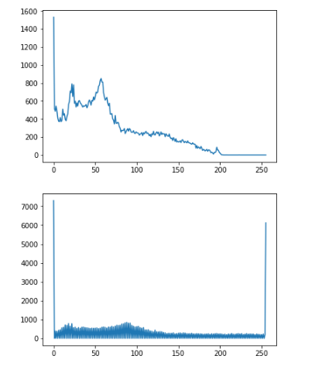

**2) Again doing stretching with 20% this time**

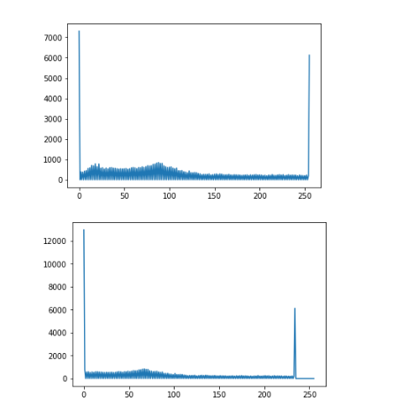

if range was not increased to 20% then result would have been same as 1st stretching.